**PRACTICAL 5**

**Q.  SPI: Camera Connection and Capturing Images using SPI**

**What is the Raspberry Pi Camera?**

* The Raspberry Pi Camera Module v2 is a high quality 8 megapixel Sony IMX219 image sensor custom designed add-on board for the Raspberry Pi, featuring a fixed focus lens.
* There are two versions of the Camera Module:

1. [The standard version](https://www.raspberrypi.org/products/camera-module-v2/), which is designed to take pictures in normal light
2. 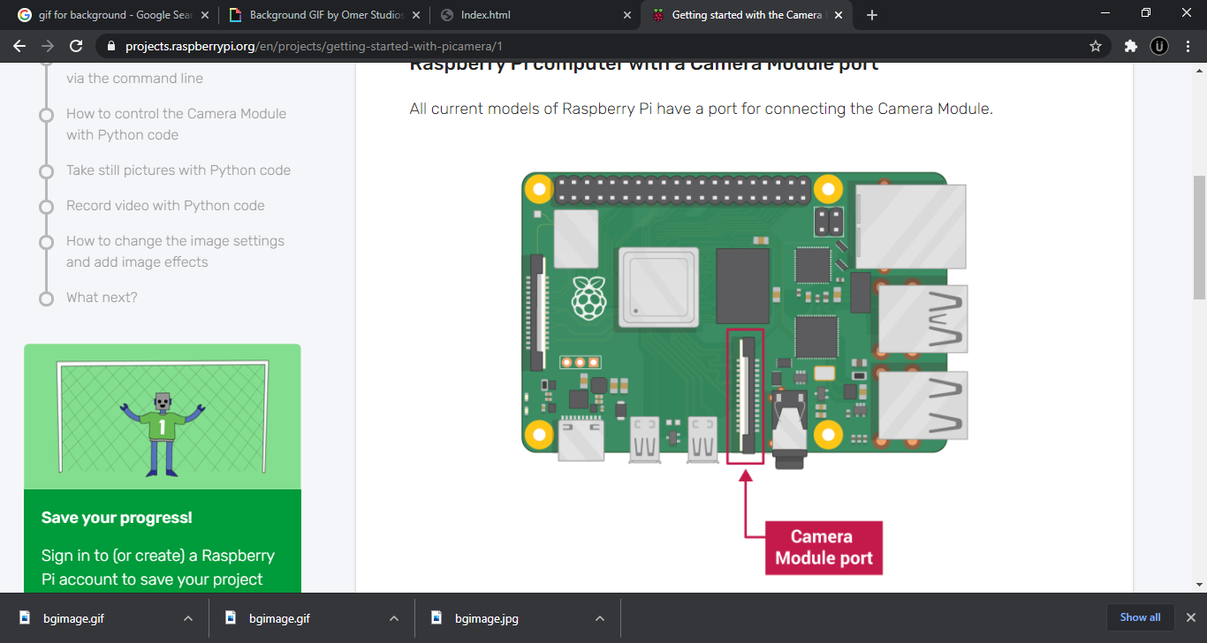[The NoIR version](https://www.raspberrypi.org/products/pi-noir-camera-v2/), which doesn’t have an infrared filter, so you can use it together with an infrared light source to take pictures in the dark

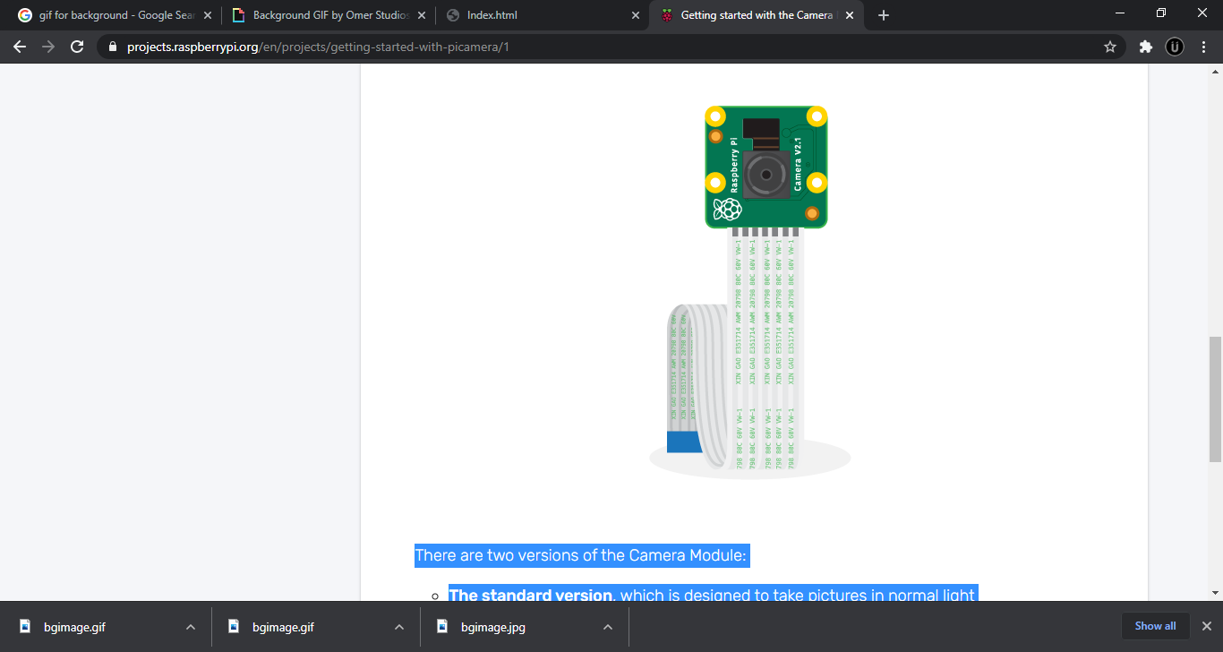

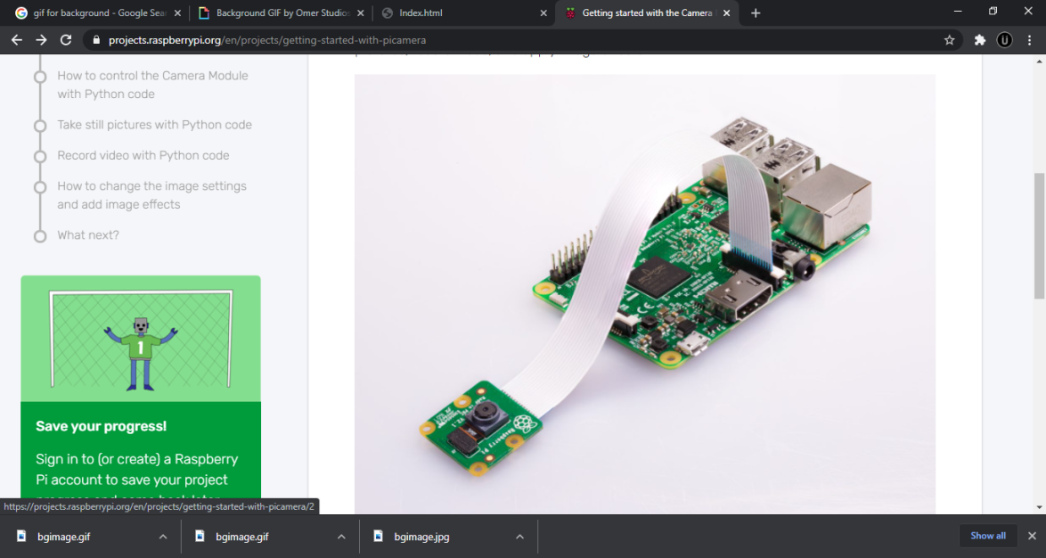

**How to use Camera in Raspberry Pi?**

* First go to Preferences in the menu and click on Raspberry Pi Configuration. Here, enable the Camera and it will ask you to reboot your system confirm and proceed. You can also use sudoraspi-config to Configure.
* Second we insert the camera strip onto the camera slot on our Raspberry Pi (next to the HDMI slot)
* Next run the following commands:

**raspistill** :The command line tool for capturing still Photographs with a Raspberry Pi camera module**raspistill –o img1.jpg**

-o: To get an output

- Img1.jpg: Name of the image file

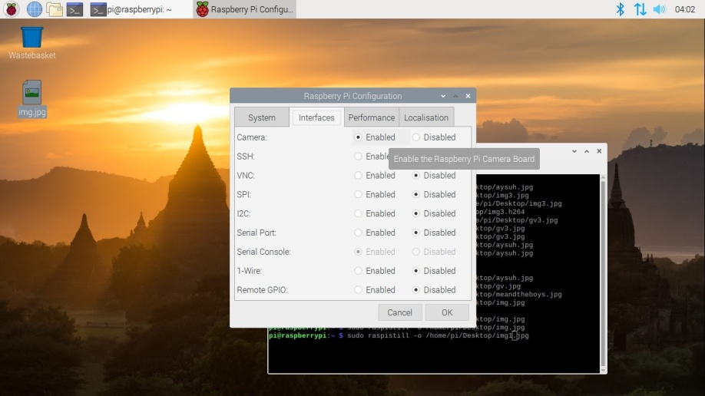

**raspistill –o cam2.jp**

In this example the camera has been positioned upside-down. If the camera is placed in this position, the image must be flipped to appear the right way up.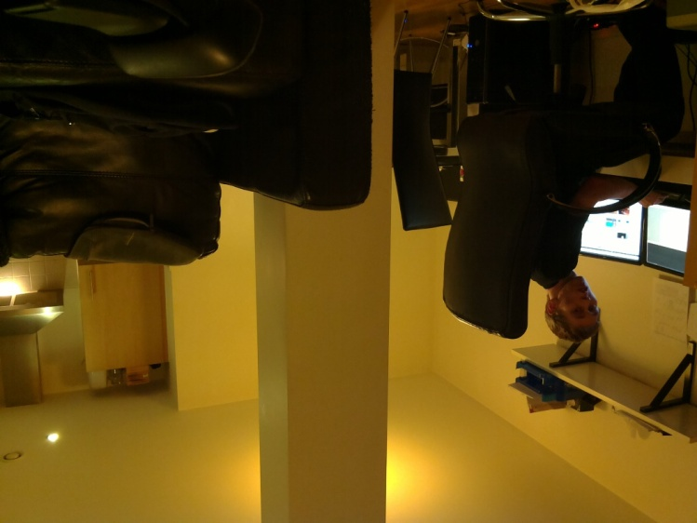

With the camera placed upside-down, the image must be rotated 180° to be displayed correctly. The way to correct for this is to apply both a vertical and a horizontal flip

**raspistill –vf -hf –o cam2.jpg**

-vf: To flip the image vertically

-hf: To flip the image horizontally

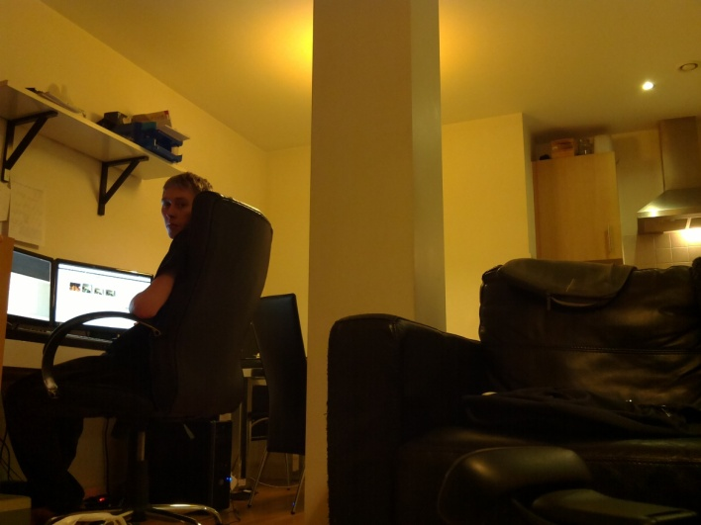

**raspivid**: The command line tool for capturing video with a Raspberry Pi camera module

**raspivid –o video1.h264:** This will save a 5 second video file to the path given

**raspivid –o video1.h264 –t 10000:**  To specify the video length taken use –t with number of milliseconds

**Using Camera module with Python**

The Pythonpicameralibrary allows you to control your Camera Module and create amazing projects.

* Open a Python 3 editor, such as **Thonny Python IDE**:
* Open a new file and save it as camera.py.

Note: it’s important that you never save the file as picamera.py.

* Enter the following code:

**importpicameracamera=picamera.PiCamera()camera.capture('image.jpg')camera.hflip=Truecamera.vlip=True**

* Save and run your program. The camera preview should be shown for five seconds and then close again.